**Open Source Graphics & Animation Tools**



**SHINCHAN SCENE**

**MID TERM EVALUATION**

**Submitted to**

**Dr. Durgansh Sharma Sir**

**Professor, Cybernetics SCS, UPES**

**Submitted By**

Name: SHIVANSH SINHA

Roll No: 57

SAP ID: 500068985

DATE-19TH March , 2020

B. Tech CSE (OSOS) Department of Cybernetics

COMPUTER SCIENCE & ENGINEERING

**AIM:** MODELLING SHINCHAN’S HOUSE.

**SOFTWARE REQUIRED:** BLENDER.

**PREVIOUS KNOWLEDGE REQUIRED:** BASIC KNOWLEDGE OF BLENDER AND BASIC ARTISTIC SKILLS.

**ADDITIONAL INFORMATION:** THIS PROJECT IS DESIGNED BY USING A SINGLE MESH OBJECT (CUBE).THE WHOLE PROJECT IS PERFORMED IN THE EDITING MODE BY USING THE EXTRUDE AND THE LOOP CUT TOOL IN THE EDITING MODE.

**PROCEDURE:**

**STEP1:** OPEN BLENDER.

**STEP2:** THE CUBE APPEARS BY DEFAULT.

**STEP3:** SELECT THE VISIBLE OBJECT MODE ON THE LEFT HAND CORNER AS SHOWN IN THE PICTURE.

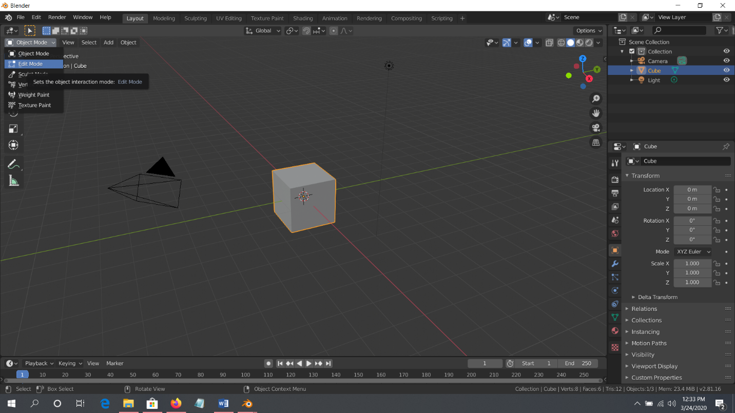

**STEP4:** SELECT THE EXTRUDE OPTION FROM THE DIALOGUE BOX ON THE LEFT.

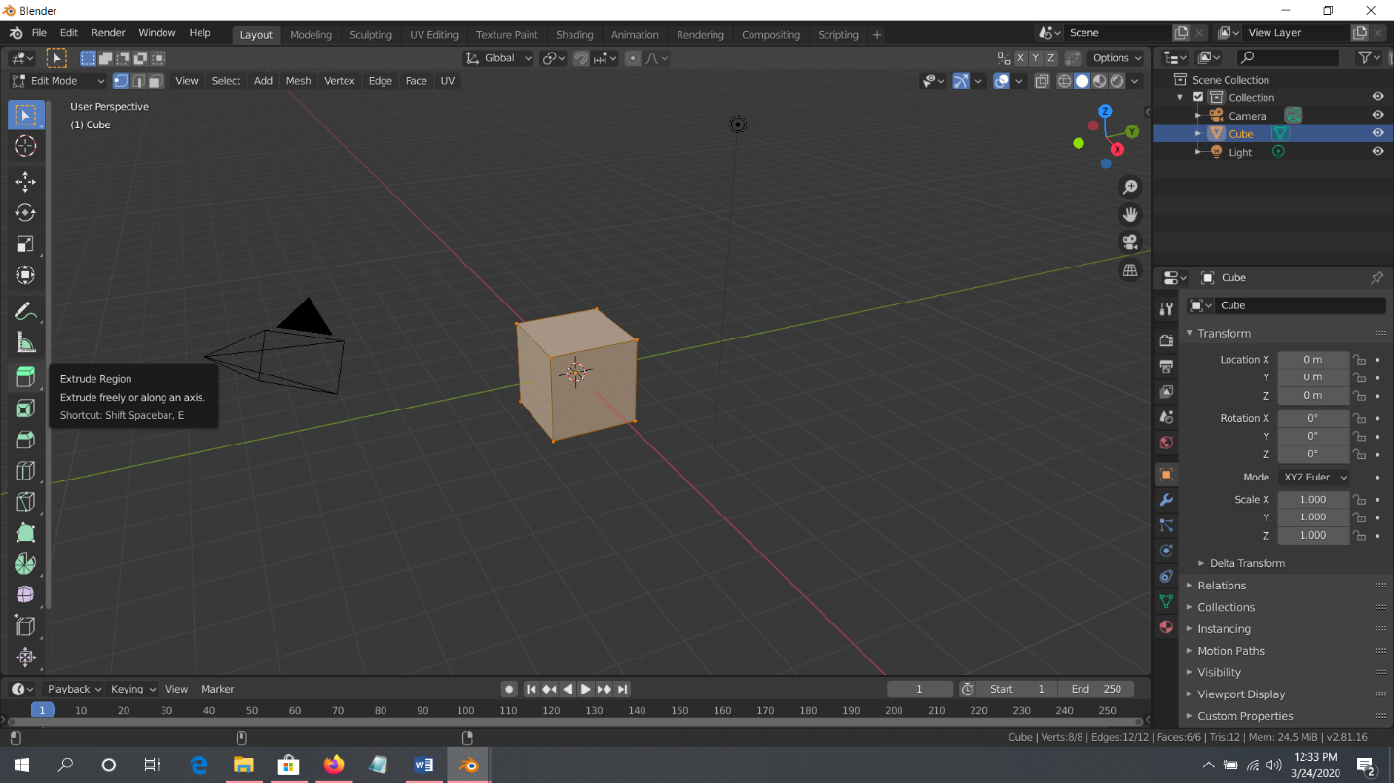

**STEP5:** EXTRUDE THE CUBE IN THE DESIRED FORM.

**STEP6:** USE SHIFT KEY TO SELECT MULTIPLE FACES USING THE FACE TAB FROM THE THREE TABS APPEARING ON THE LEFT TOP OF THE EDITING MODE.

**STEP7:** USE CTRL+R AS A SHORTCUT KEY TO CUT THE CUBE FOR INCREASING THE NUMBER OF FACES AND EDGES FOR MORE PERFECTION.

**STEP8:** USETHE LOOP CUT TOOL TO CREATE MORE CUTS INSIDE THE OBJECT SO AS TO MAKE MORE CHANGES AND ENHANCE THE PROJECT.

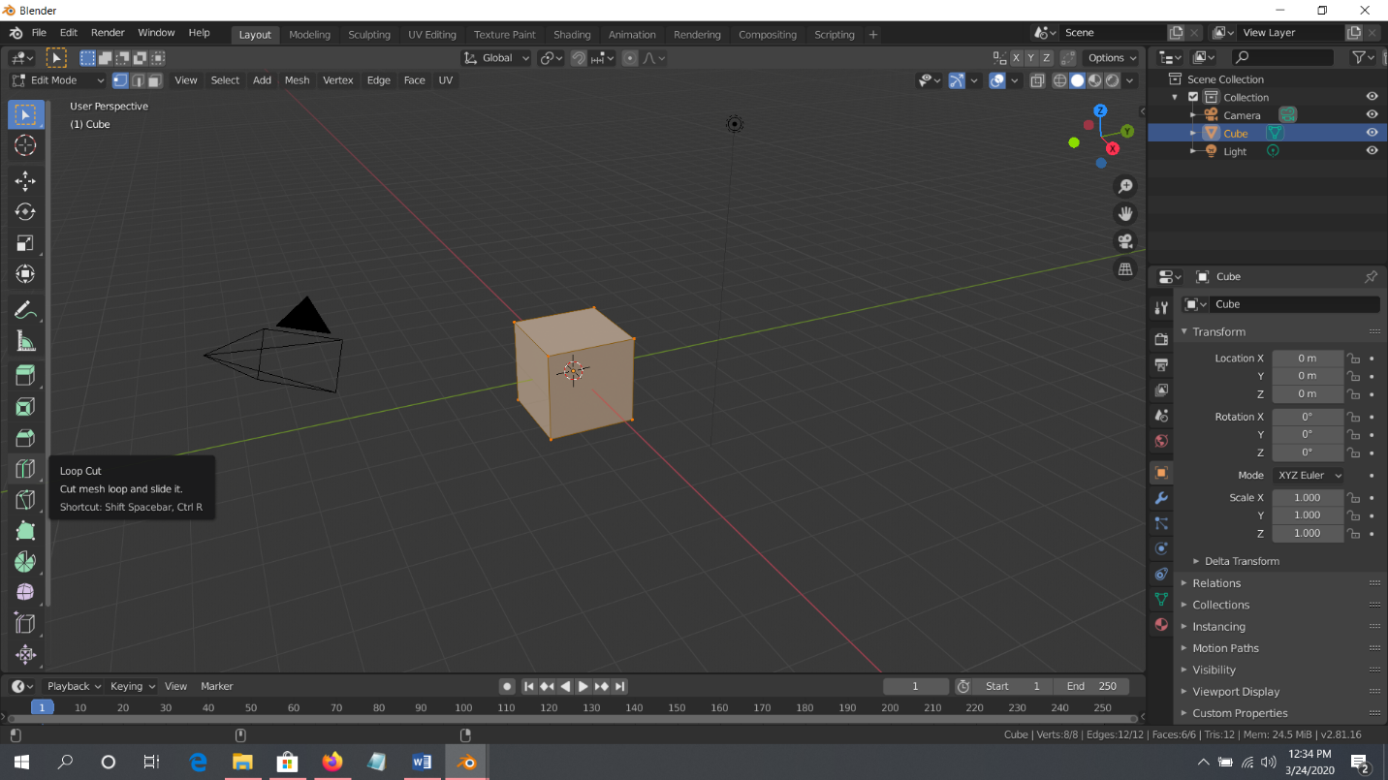

**STEP9**: USE A PICTURE FROM THE INTERNET FOR THE REFERENCE.

**STEP10:** USE BEVEL TOOL TO SCULPT THE EDGES OF THE OBJECT AS REQUIRED.

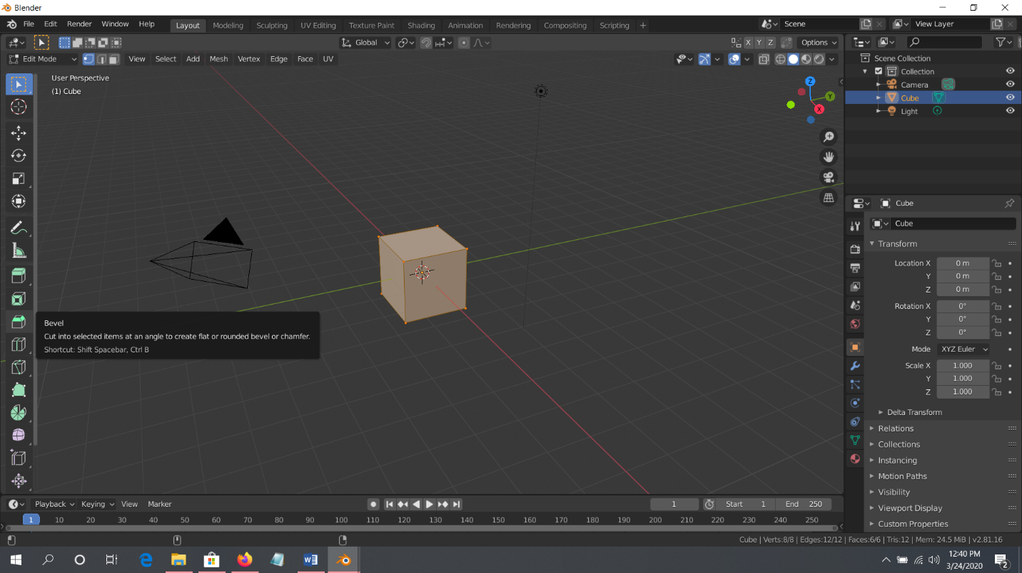

**STEP11:** WHEN THE OBJECT IS READY GO BACK TO THE OBJECT MODE AND RENDER THE OBJECT FORMED. USE THE COLOUR OF YOUR LIKE FOR THE BUILDING.

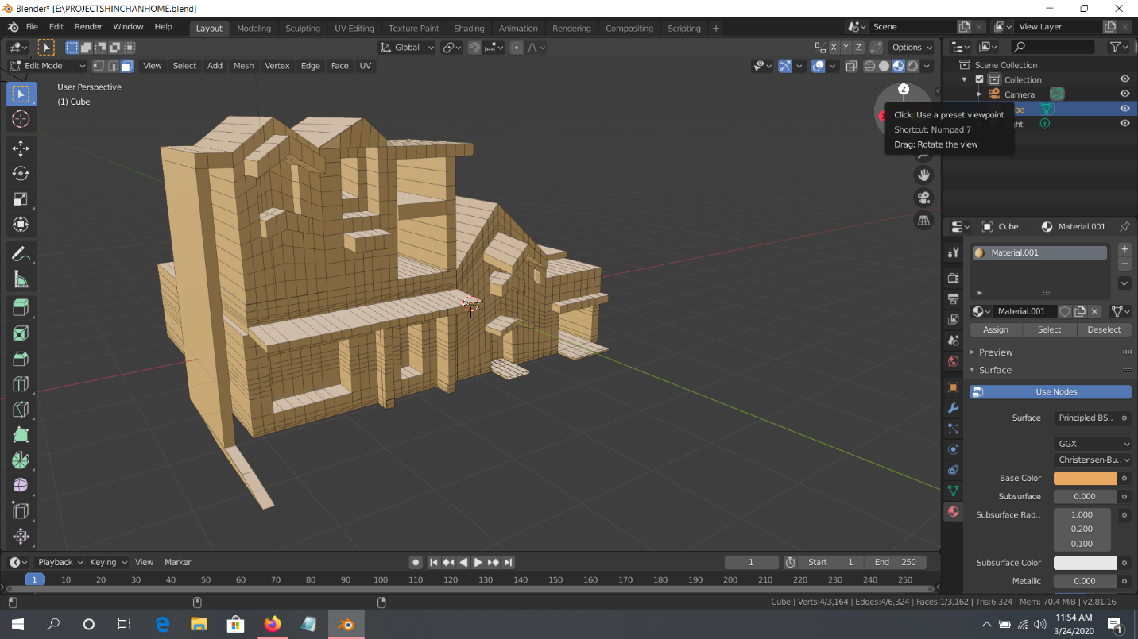

**FINAL OUTCOME**

